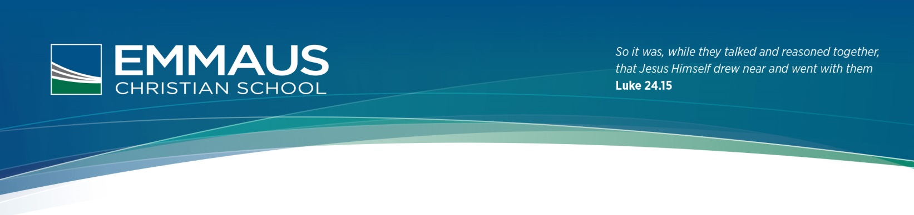1 February, 2016

Yr. 7 iPad Programme 2016

Dear Parents/Carers,  
Welcome to the Emmaus Christian School iPad programme. Attached is a copy of the Student iPad User agreement, an initial list of apps required to be installed on your child’s device and the Emmaus Student Network and Technology Agreement. It is essential that you read over the documents with your child, discuss the guidelines outlined, sign all documents and return them promptly to Homeroom. If you have any questions or require assistance with setting up an iTunes account or applying the suggested restrictions, please contact me at [toni@emmaus.act.edu.au](mailto:toni@emmaus.act.edu.au). I am available afters school on a Wednesday afternoon should you require any assistance with applying the settings required below.  
  
The iPad is a learning tool and does not replace the use of books, pencils, pens or face to face interaction between students and teachers. Not all teachers will require the device to be used in their lessons; however, it is expected that your child will bring the iPad to school fully charged each day, along with their diary and stationary for each class. If your child loses access to the iPad as a consequence of breaching the iPad User Agreement or as a punishment for behaviour or attitude at home, we encourage the partnership between home and school to ensure that they have access to the iPad through an agreed implementation of a passcode that only parents or carers and teachers know.

The majority of Apps required are free; however, an iTunes card will be sent home with your child by the end of the first week of term to cover the cost of any paid Apps. Teachers may request additional Apps to be downloaded throughout the year but the cost of these will be covered by Emmaus if they are not free. The first page of the device is to be used solely for Apps required for School and should not have any games installed on it. The tray or dock at the bottom of the page should contain Safari, Edmodo, Word or Pages and the Calendar. The Apps can be organised into subject folders of your choice. The image selected for the Lock and Home Screen needs to be appropriate for school.

**I ask that you apply the following restrictions (under settings) to your child’s device:-**

1. Install a passcode to access the iPad
2. Turn Facetime off
3. Stop In-App purchases
4. Under the Allowed Content, set the ratings for Australia;
   * + - 1. Remove explicit content under Music and Podcasts
         2. Set movies to PG
         3. TV shows to PG
         4. Remove Explicit Sexual Content under Books
         5. Remove Explicit Language from Siri
         6. Limit Adult Content under Allowed Websites

**Further Suggestions:**

Regularly backup the iPad using iCloud or connect to iTunes on your computer, in case of loss or damage.

Ensure Find My iPad is installed to locate the device when it is connected to Wi-Fi

Set guidelines with your child regarding access to games etc. when using the iPad at home.

Toni Falusi  
ICT Teacher